HANOI UNIVERSITY OF SCIENCE AND TECHNOLOGY

School of Information and Communications Technology

**Usecase Analysis**

Phân tích ca sử dụng cho hệ thống

BFR – BikeForRent

Giảng viên phụ trách: Nguyễn Thị Oanh

Sinh viên: Nguyễn Thế Duyệt – 20200118

Vũ Duy Bách – 20200060

Trần Đức Duy – 20200115

Nguyễn Tấn Dũng - 20200103

Contents

1. Usecase 01 – Sign Up 4

1.1. Sequence Diagram 4

1.2. Class Diagram 5

2. Usecase 02 - Store Manager Sign Up 5

2.1. Sequence Diagram 5

2.2. Class Diagram 6

3. Usecase 03 - Rent Bike 6

3.1. Sequence Diagram 6

3.2. Class Diagram 7

4. Usecase 04 - Request Unloking Bike 8

4.1. Sequence Diagram 8

4.2. Class Diagram 9

5. Usecase 05 - Account Information Update 10

5.1. Sequence Diagram 10

5.2. Class Diagram 11

6. Usecase 06 - Update Bike Information 12

6.1. Sequence Diagram 12

6.2. Class Diagram 13

7. Usecase 07 - Add Bike 14

7.1. Sequence Diagram 14

7.2. Class Diagram 15

8. Usecase 08 - Delete Bike 16

8.1. Sequence Diagram 16

8.2. Class Diagram 17

9. Usecase 09 - Delete Account 18

9.1. Sequence Diagram 18

9.2. Class Diagram 19

10. Usecase 10 - Accepting Banning User Request 20

10.1. Sequence Diagram 20

10.2. Class Diagram 21

11. Usecase 11 - Accepting Store Management Sign Up Request 22

11.1. Sequence Diagram 22

11.2. Class Diagram 23

12. Usecase 12 - Accept Banning Bike Request 24

12.1. Sequence Diagram 24

12.2. Class Diagram 25

13. Usecase 13 - Accept Unlocking Bike Request 25

13.1. Sequence Diagram 25

13.2. Class Diagram 26

14. Usecase 14 - Request Banning Bike 26

14.1. Sequence Diagram 26

14.2. Class Diagram 27

15. Usecase 15 - Request Banning User 27

15.1. Sequence Diagram 27

15.2. Class Diagram 28

# Usecase 01 – Sign Up

## Sequence Diagram

## Class Diagram

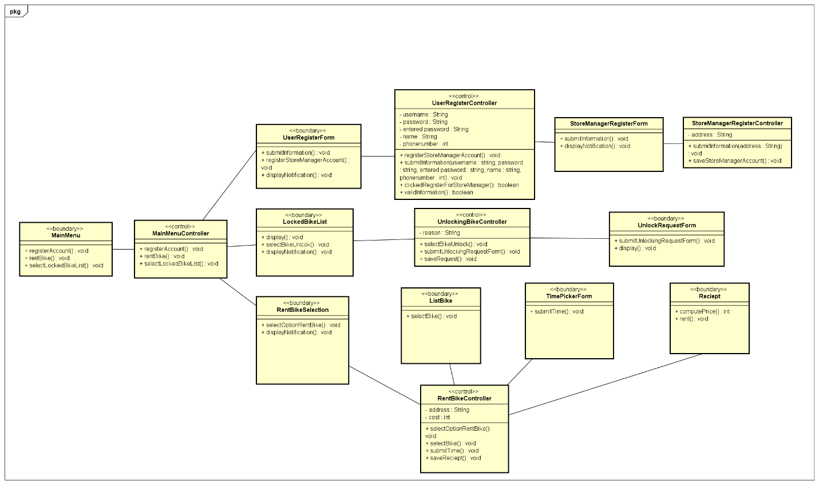

# Usecase 02 - Store Manager Sign Up

## Sequence Diagram

## Class Diagram

# Usecase 03 - Rent Bike

## Sequence Diagram

## Class Diagram



# Usecase 04 - Request Unloking Bike

## Sequence Diagram

## Class Diagram



# Usecase 05 - Account Information Update

## Sequence Diagram

## Class Diagram

# Usecase 06 - Update Bike Information

## Sequence Diagram

## Class Diagram

# Usecase 07 - Add Bike

## Sequence Diagram

## Class Diagram

# Usecase 08 - Delete Bike

## Sequence Diagram

## Class Diagram

# Usecase 09 - Delete Account

## Sequence Diagram

## Class Diagram

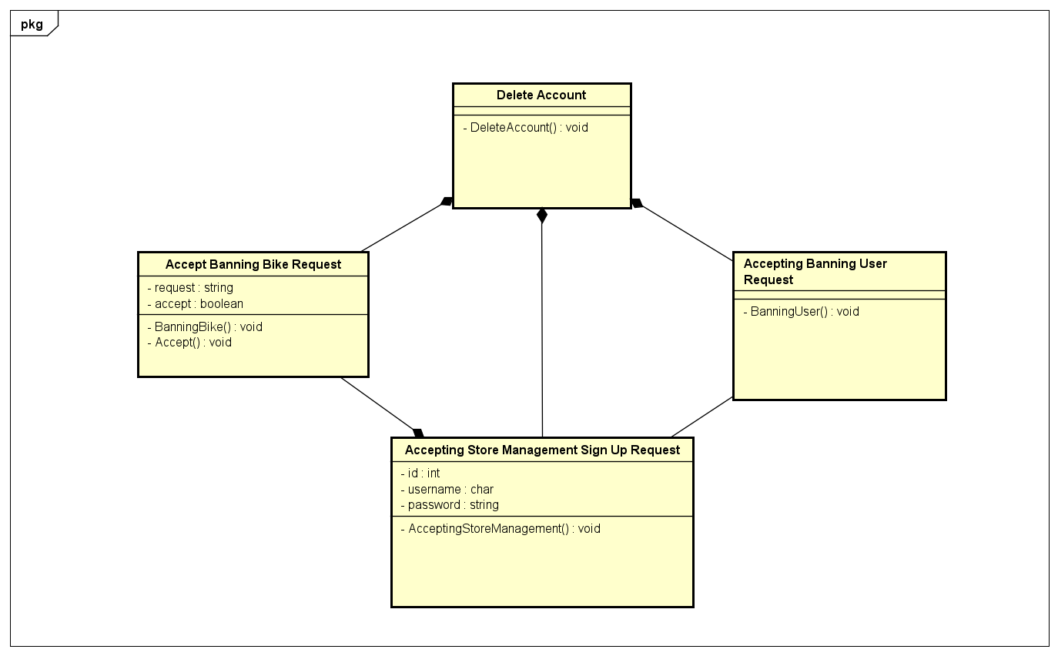

# Usecase 10 - Accepting Banning User Request

## Sequence Diagram

## Class Diagram



# Usecase 11 - Accepting Store Management Sign Up Request

## Sequence Diagram

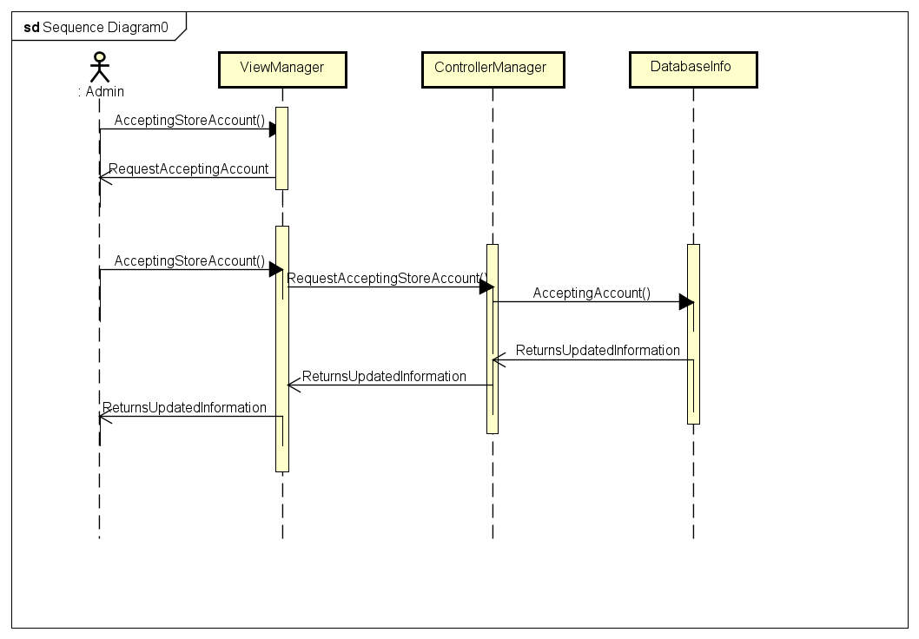

## Class Diagram

# Usecase 12 - Accept Banning Bike Request

## Sequence Diagram

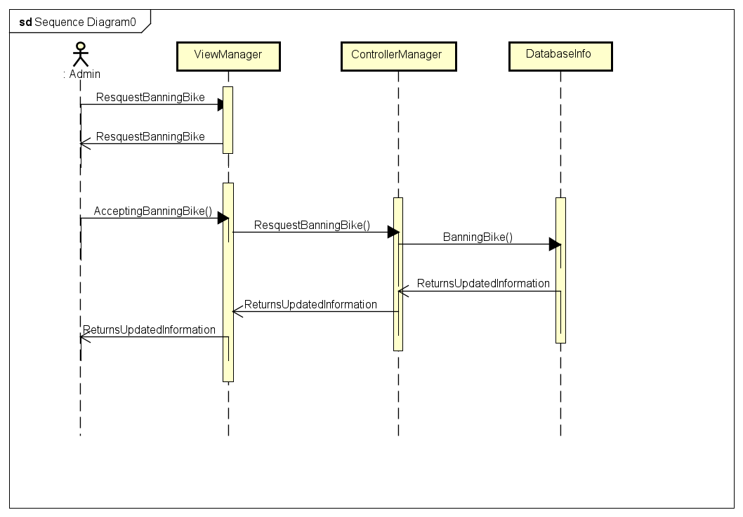

## Class Diagram

# Usecase 13 - Accept Unlocking Bike Request

## Sequence Diagram

## Class Diagram

# Usecase 14 - Request Banning Bike

## Sequence Diagram

## Class Diagram

# Usecase 15 - Request Banning User

## Sequence Diagram

## Class Diagram

